FY 2025-2026
Community Development Block Grant
Application Kit

City of Danville, VA
Department of Community Development
Housing & Development Division
427 Patton Street, Room 211
Danville, VA 24541

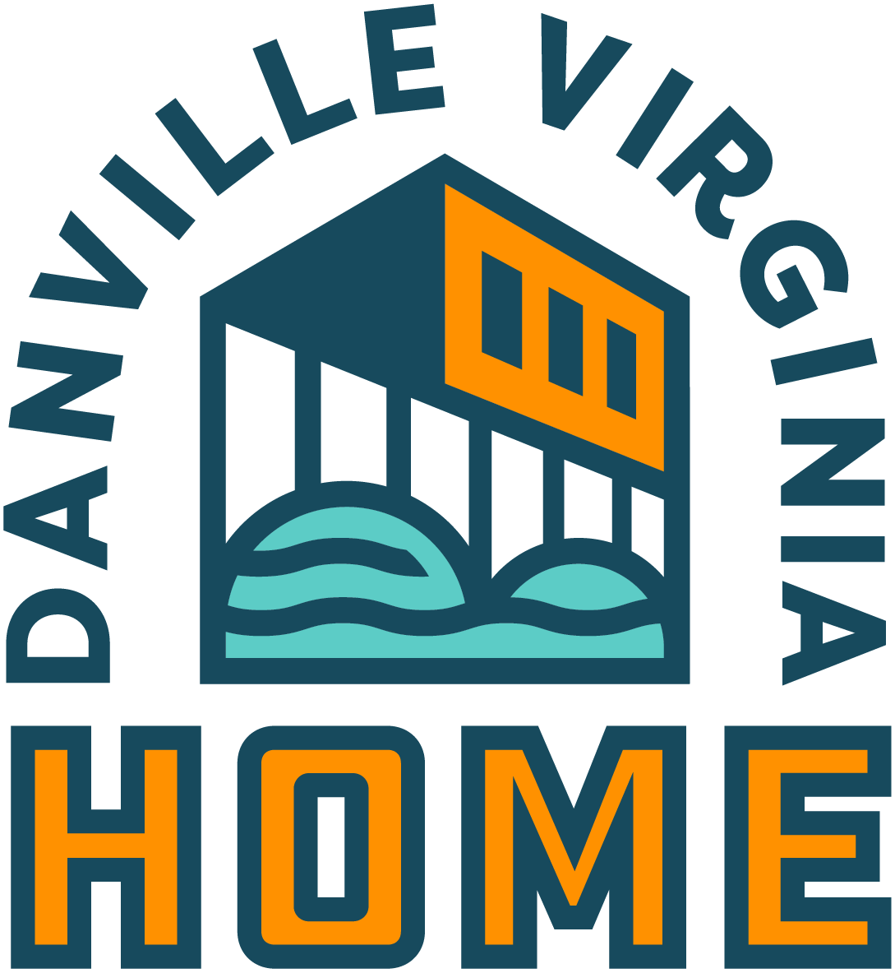

Applicant Instructions
Application Deadline:
Applications must be received by Housing & Development Division Staff no later than
5:00 P.M. on Monday, April 7th, 2025
Please complete all forms that are included in this application package. Attach supporting documentation as required.
Submit two (2) copies of the application. Submissions should be unbound, on white paper with the pages numbered.
All applicants are encouraged to contact Dana Kern, Housing and Redevelopment Specialist at 434-799-5260, ext. 2508, or kerndn@danvilleva.gov with any questions regarding the completion of the application.
- STAFF MAY REQUIRE ADDITIONAL INFORMATION to be submitted in addition to that which is in the application during the review process.
- STAFF MAY REQUIRE THE APPLICANT TO PERFORM WORK AND/OR ACTIVITIES that were not specifically mentioned in the original application in order to meet HUD/Community goals.
- PREMATURE COMMITTING OR EXPENDING FUNDS. Project costs are not eligible for CDBG reimbursement if they have been committed or spent prior to Environmental Clearance and execution of the subrecipient agreement.
- AN ENVIRONMENTAL REVIEW IS REQUIRED FOR EACH PROJECT RECEIVING CDBG FUNDING. Depending on the type of project, this process takes 120 days or more to complete and can be a significant impact on the time required to implement a project.
If Construction/Rehab Application:
- CONSTRUCTION OR REHABILITATION PROJECTS MAY REQUIRE THAT CONSTRUCTION WORKERS BE PAID IN ACCORDANCE WITH DAVIS-BACON WAGE REGULATIONS (D/B). A determination of the D/B applicability will be made prior to entering a contract and the start or work. If D/B applies to the project, labor costs for the project may increase.
- THE CITY OF DANVILLE WILL PLACE A MORTGAGE ON ACQUISITION AND/OR REHAB CONSTUCTION PROJECTS FUNDED BY THE CDBG PROGRAM. The type and duration of liens will depend on the type and amount of the project being funded.
- A SITE VISIT MAY BE CONDUCTED. The City’s Housing & Development Division Staff may request a tour of the agency. Notification will be given to the applicant prior to the site visit.
- ALL CDBG-FUNDED PROJECTS MUST BE ACCESSIBLE TO PERSONS WITH DISABILITIES. Information, participation, communications, and services regarding your project must be accessible to persons with disabilities in compliance with the Americans with Disabilities Act (ADA).

I have read and understand the above information:
AGENCY NAME: _________________________________________________________________
AUTHORIZED AGENCY SIGNATURE: _______________________________________________
PRINTED NAME AND TITLE: _______________________________________________________

CDBG General Policies
(24 CRF 570.200)
The primary objective of the CDBG Program is the development of viable urban communities by providing decent housing and a suitable living environment, and expanding economic opportunities, principally for persons of low and moderate income. Funds must be used so as to give maximum feasible priority to activities that will carry out on of the three (3) broad national objectives of: (1) benefit to low- to moderate- income families; (2) aid in the prevention or elimination of slums or blight; or (3) activities designed to meet other community development needs having a particular urgency because existing conditions pose a serious and immediate threat to the health or welfare of the community where other financial resources are not available to meet such needs. At least 70% of the total amount of CDBG funds must be used for activities that benefit low- to moderate-income persons over a one-year period; and at least 51% of the beneficiaries or individual activities designed to benefit low- to moderate-income persons must be certified as being low- to moderate- income.

Project Selection Criteria

- Completeness of application
- Detailed project description
- Adequacy of project eligibility documentation
- Adequacy of national objective justification (i.e., low/mod benefit rationale)
- Project fits into the community priorities established by the Consolidated Plan
- Projects can be completed within a reasonable time frame
- Performance in carrying out previously awarded CDBG funds
- Prior experience with CDBG related activities and/or
- Prior experience with other grant programs, and proven record carrying out similar projects in the community

- Financial capacity as indicated by audited financial statements and banking/credit references

- Financial stability (not total dependence on CDBG funds) as indicated by other funding sources and amounts, over time

- Adequate staffing (number of staff and qualifications)
- Organizational strength, including:
  - Record keeping methods
  - Filing system
  - Financial system
  - Existence of a written procedure manual for financial management and personnel

Applicant Information and Project Abstract
1. | Project Name:
2. | Eligible CDBG Funding Activity:  (See Exhibit A)
3. | CDBG Funding Year: FY 2025-2026
4. | Legal Name of Applicant Organization:
5. | Address:
6. | Telephone: | 7. | DUNS#
8. | Federal Tax ID #: | 9. | Applicant’s hours of operation:
10. | Type of Organization:  € Non-profit € For-profit  € Other:
11. | Name of Principle Contact Person:
12. | Title: | 13. | Email address:
14. | Amount of CDBG funds requested: $
15. | Funds committed from other sources: $
16. | Total project cost (Line 14 + Line 15): $
17. | Location of proposed project (street address):

I certify that all provided information is true and accurate.
_____________________________________________________
Signature

Description
Briefly describe the proposed project, including the need and/or problem the proposed program will address as it relates to the goals identified in the Consolidated Plan. The narrative should also state the population that will be served or the area benefitting from the funding/program. In addition, the work that will be performed, including the activities to be undertaken or the services to be provided, the goals and objectives, method of approach, and the implementation schedule. Additional sheets may be attached if necessary.

Indicate how your clients, or target population, will be identified. Also, provide an estimate of the number of clients to be served and describe them in terms of age, gender, ethnicity, income level, and other defining characteristics.

Provide a detailed description of how the program will be carried out. Include who will carry out the activities, the location in which they will be carried out, the time frame in which they will be carried out, and the frequency in which activities and services will be provided.

Describe the efforts that will be made by the agency and partners to promote the programs and/or services offered. Include how isolated individuals will be reached and any efforts that will be made to ensure clients are able to have access to the facility. Include how the facility complies with the Americans with Disabilities Act (ADA) requirements regarding disabilities.

Performance Measurement
Describe what you expect to accomplish with your service in terms of:
- OUTPUT (e.g., 50 participants in the literacy program) __________________________

- OUTCOME (e.g., 60% of participants with reach a 2nd grade reading level)
______________________________________

CDBG Eligibility of Public Service Activities

- Check ALL that apply to your proposed activity.

- Child Care € Health Care
- Recreation programs € Education programs
- Public Safety Services € Fair Housing Activities
- Services for senior citizens € Services for homeless people
- Drug abuse counseling € Energy conservation counseling and testing
- Welfare € Homebuyer Down payment assistance
- Paying for the operating costs and maintaining the portion or a facility in which one or more of the above services are provided.

- Describe how your proposed activity is either a new public service or a quantifiable increase in the level of an existing public service. Indicate what criteria will be used to show your successful accomplishments.

CDBG Statutory Objective Justification – Low and Moderate Income Benefit

- Area Benefit – Describe how the proposed public service is available to all the residents in a primary residential area and how you determined that at least 51% of those residents are low- to moderate-income persons. NOTE: Public service activities CANNOT be qualified as an Area Benefit Activity.

- Limited Clientele – If the proposed public service activity is limited to a specific group of people, indicate which of the three categories of limited clientele activities best describes the activity by placing a checkmark in the appropriate box. At least 51% of the group must be considered low- to moderate-income
€ Presumed benefit – place a checkmark in the box that describes the beneficiaries of the proposed service:
  - Abused children € Battered spouses
  - Elderly persons € Severely disabled adults (use census data
to define
  - Homeless persons € Illiterate adults
  - Persons living with AIDS € Migrant farm workers

- Family size and income – check this box if you intend to utilize household income surveys to document the size and annual income of each person receiving the benefit. Note: at least 51% or the program beneficiaries must be persons whose total household income does not exceed the limits in Exhibit “C”.

- Nature and location of activity – check this box if the nature and location of the activity are such that it will be utilized predominately by low- to moderate-income persons. For example, a day care center designed to serve residents of a public housing development.

- Prevention and/or Elimination of Slums and Blight – only the capital cost of building rehabilitation or demolition can be qualified as a slums and blight activity.

Line Item Budget Form – Service Projects
Name of Applicant: Project Name:
Instructions: Please use the following format to present your proposed line item budget. In column A, list the items for which you anticipate the need for CDBG funds. In Column B, provide the calculation explaining how you arrived at the estimated cost of the line item. In Column C, provide the projected request for CDBG funds. On Attachment C, provide a description of other funds as well as volunteer and/or donated services/resources to be used in the project.
A B C
Budget Item Calculation CDBG Request

PERSONNEL
Salaried Positions – Job Titles | Provide rate of pay (Hourly/salary) and percentage of time spent on project (full-time equivalent) or hours per week
Salaries Total
Fringe Benefits
PERSONNEL TOTAL | Total of personnel and fringe benefits
OPERATING COSTS | Provide description of how you arrive at total for each line item
Supplies
Equipment
Rent/Lease
Insurance
Printing
Telephone
Travel
Other (Provide full description)
TOTAL OPERATING COSTS
CONTRACT SERVICES
TOTAL CONTRACT SERVICES
BUDGET TOTAL

Line Item Budget Form – Construction/Acquisition Projects
Name of Applicant: Project Name:
Instructions: Please use the following format to present your proposed line item budget. In Column A, list the items for which you anticipate using CDBG funds for. In Column B, provide the calculation explaining how you arrived at the estimated cost of the line item. In Column C, provide the projected request for CDBG funds. On Attachment C, provide a description of other funds as well as volunteer and/or donated services/resources to be used in the project.
A B C
Budget Item Calculation CDBG Request

DETAIL THE SCOPE OF
WORK AND COST ESTIMATE
FOR EACH ITEM

OTHER CONTRACT SERVICES
BUDGET TOTAL

Budget Narrative Attachment
- Describe all other SECURED funding sources that will be used in addition to the requested CDBG funds. Provide the source of funds, amounts, and a detailed description of how the funds will be used.

- Describe your plans to seek new funding to supplement CDBG funding. Describe the sources to which you will apply, the amounts sought, and the proposed use of those funds.

- Describe your use of donated goods and services. Estimate the value of these services and describe how you arrived at these amounts.

- Please provide an explanation for any unusual budget expenditures listed in the line item budget on the previous page.

- Explain why you consider your program costs to be reasonable.

Applicant Organizational Information
Financial Capacity
Describe the agency’s current operating budget, itemizing revenues, and expenses. Identify Commitments for ongoing funding. Describe the agency’s fiscal management, including financial reporting, record keeping, accounting systems, payment procedures, and audit requirements.

Monitoring
Briefly describe how you will monitor progress in implementing the program. Attach copies or all data collection tools that will be used to verify achievement of program goals and objectives. Describe who will be responsible for monitoring progress.

Insurance/Bonding/Worker’s Compensation
State whether the agency has liability insurance coverage, in what normal amount, and with what insuring agency. State whether the agency pays all payroll taxes and worker’s compensation as required by federal and state laws. State whether the agency has fidelity bond coverage for principal staff who handle the agency’s accounts, in what amount, and with what insuring agency.

Please attach the following to your application:
- Articles of Incorporation/Bylaws
- Non-profit determination (tax exemption letter from the IRS and/or state)
- List of the Board of Directors members
- Organizational chart
- Resumes of chief program administrator and chief fiscal officer
- Financial Statement and last audit
- Banking reference

Exhibit “A” – CDBG Basic Eligible Activities

The following activities may be funded by the CDBG Program, so long as they meet one or more of the National Objectives.
- Acquisition of real property by purchase, long-term lease (15+ years), donation, or otherwise, of real property for any public purpose, subject to limitations.
- Disposition of real property acquired with CDBG funds through a lease or donation, or otherwise, or its retention for public purposes.
- Acquisition, construction, reconstruction, rehabilitation, or installation of public facilities and improvements, except buildings for general conduct of government. Eligible facilities include those serving persons having special needs such as homeless shelters, convalescent homes, hospitals, nursing homes, battered spouse shelters; half-way houses for runaway children, drug offenders or parolees, group homes or mentally retarded persons; and temporary housing for disaster victims.
- Clearance, demolition, and removal of building and improvements, including movement of structures to other sites.
- Provision of public services (including labor, supplies and materials) such as those concerned with child care, health care, education, job training public safety, fair housing counseling, recreation, senior citizens, homeless persons, drug abuse counseling and treatment, and energy conservation counseling and testing. The services must meet each of the following criteria.
  - A service must either be new or be a quantifiable increase in the level of a service above that which has been provided with state or local funds in the previous twelve calendar months: and
  - The amount obligated for public services shall not exceed 15 percent of the annual grant plus 15% of the program income received from the previous year.
- Removal of material and architectural barriers which restrict the mobility and accessibility of elderly or handicapped persons to publicly owned and privately owned buildings, facilities, and improvements.
- Rehabilitation of privately and publicly owned building and improvement for residential purposes.
- Rehabilitation of publicly or privately owned commercial or industrial buildings, except that the rehabilitation of such buildings owned by a private for-profit business is limited to improvements to the exterior of the building and the correction of code violations.
- Improvements to buildings to increase energy efficiency.
- Rehabilitation, preservation, or restoration or historic properties.
- Provision of credit, technical assistance, and general support (including peer support programs, counseling, childcare, transportation, etc.) for the establishment, stabilization, and expansion or micro enterprises. A micro enterprise is a business with five or fewer employees, one or more whom owns the business.
- Provision of assistance to private for-profit businesses where appropriate to carry out an economic development project. Any project funded must be able to document the creation or retention of a certain number of jobs, depending on the type of project proposed.

Exhibit “B” – Recordkeeping Responsibilities

Chosen applicants will be required to sign a contract with the City which will state all the requirements and expectations for the applicant. In general, the following will apply to all applicants:
- Written records justifying all expenditures must be kept for a period of not less than three (3) years after the full amount of the grant has been expended. These records will be subject for review by both the City and/or HUD at any time during this three (3) year period.
- You will be required to maintain insurance that meets the City’s minimum insurance standards. A copy of the policy must be provided to the City within ten (10) days of execution of the contract.
- You must agree to administer the CDBG program in accordance with the OMB Circular A22, “Cost Principles for Non-Profit Organizations,” and Attachment F of MOB Circular A-110.
- In accordance with the Office of Management and Budget Circular A-133, the federal government requires that organizations expending $300,000 or more must choose one of the three ways of meeting this requirement and state which method they choose:
  - If your agency already conducts audits of all its funding sources including CDBG, the agency must submit a copy of its most recent audit, and may, at its discretion, include the CDBG portion of the audit cost in its CDBG project budget.
  - If your agency already conducts audits of its other funding sources but has neither received nor included CDBG in the past, the scope of the audit would be modified to incorporate CDBG audit requirements. The associated cost of the augmentation could be included in the CDBG project budget, accompanied by the auditor’s written cost estimate.
  - If your agency does not have a current audit process in place, your agency will be required to include a 10 percent set aside in the CDBG project for the provision of an audit.
- You will be required to provide quarterly reports stating the total number of persons served, including additional income and demographic information by completing the form provided at the time of signing.
- Your will be required to obtain written proof of income of each person or household which you assist, unless your clients are abused children, battered spouses, elderly persons, handicapped persons, homeless persons, illiterate persons, or migrant farm workers.
- You must have a written policy designed to ensure your facilities are free from illegal use, possession, or distribution of drugs or alcohol.
- If any income is derived from the activities funded by CDBG, that income must be returned to the City as program income.
- IN the even that HUD should determine that CDBG funds were improperly spent, and that money should be reimbursed to the U.S. Treasury, your organization will be responsible for this reimbursement.

